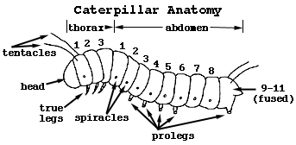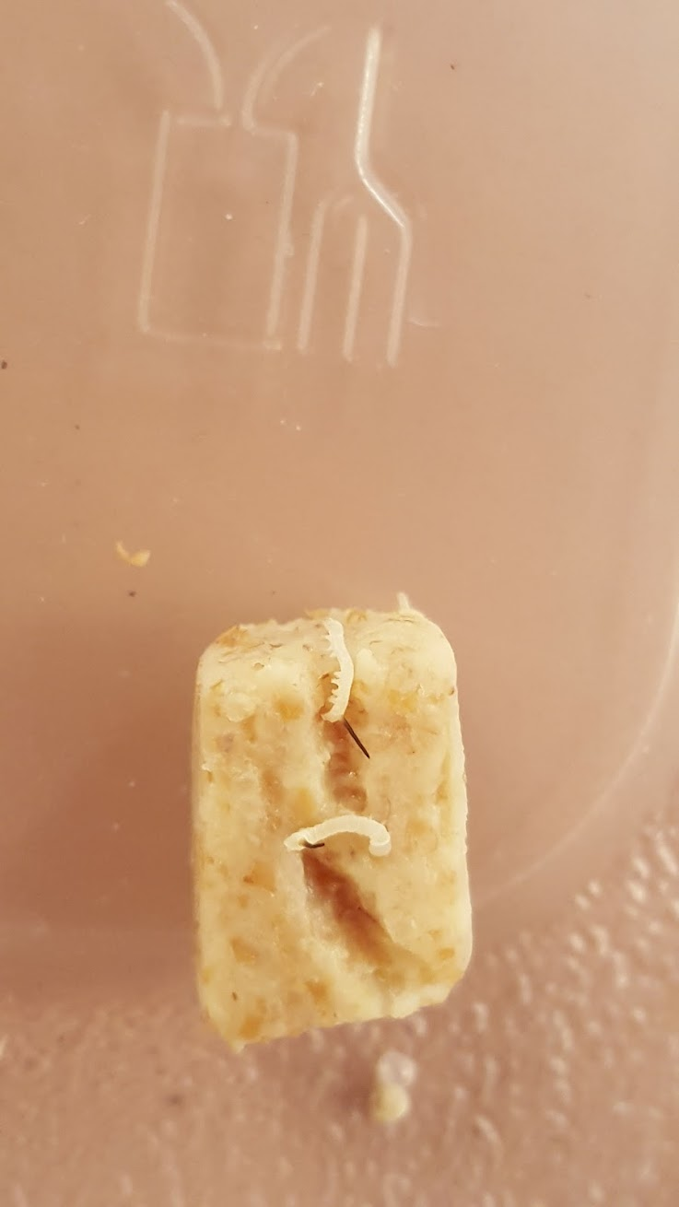**January 27th 2017**

Tail Spine/Horn

ProLegs

True Legs

(3 per side)

Head





